Title: Week 2 Task – Exploratory Data Analysis and Visualization

Name: Asfina magi
Date: 21/08/2026

1. Introduction
Customer churn is one of the most critical challenges faced by businesses in the telecommunications industry. Churn refers to the phenomenon where customers discontinue their service and move to a competitor. For telecom providers, high churn rates directly impact revenue, profitability, and long-term sustainability. Understanding the underlying factors that drive churn is therefore essential for designing effective retention strategies and improving customer satisfaction.
The dataset used in this analysis is the Telco Customer Churn dataset, which contains detailed information about customer demographics, account details, service usage, and billing preferences. Key attributes include contract type, tenure (length of time a customer has been with the company), monthly charges, total charges, internet service type, and payment method. Most importantly, the dataset includes a churn label indicating whether a customer has left the company (“Yes”) or stayed (“No”). This makes it highly suitable for exploratory data analysis (EDA) aimed at uncovering patterns and correlations between customer characteristics and churn behavior.
The primary objective of this task is to perform Exploratory Data Analysis (EDA) using Python libraries such as Pandas, Matplotlib, and Seaborn. By systematically analyzing the dataset, we aim to identify trends, visualize relationships, and highlight factors that contribute to customer churn. The analysis involves computing descriptive statistics, handling missing values, and generating visualizations that reveal insights into customer behavior. Each visualization is carefully annotated with titles, labels, and legends to ensure clarity and interpretability.
Churn analysis is important because retaining existing customers is often more cost-effective than acquiring new ones. For telecom companies, reducing churn can lead to improved customer lifetime value (CLTV), stronger brand loyalty, and increased competitiveness in a saturated market. By identifying high-risk customer segments—such as those with short tenure, high monthly charges, or specific payment methods—businesses can design targeted interventions like loyalty programs, discounts, or service improvements. Ultimately, this analysis provides actionable insights that can guide decision-makers in reducing churn and enhancing overall business performance.

2. Data Overview
The dataset was loaded using Pandas and examined to understand its structure.
Code Snippet:
python
df = pd.read_csv("cleaned_telco_churn.csv")
print(df.head())
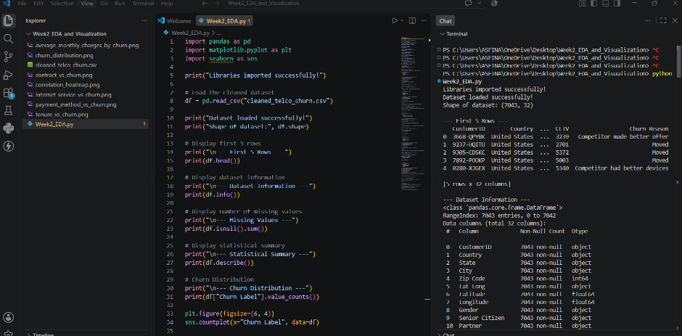
The dataset contains thousands of customer records with multiple attributes. Initial inspection confirmed that the data is clean, with minimal missing values. The statistical summary provided insights into numeric features such as tenure, monthly charges, and total charges.

3. Exploratory Data Analysis (EDA)
Each subsection includes a short code snippet, the saved visualization (PNG), and interpretation.
Churn Distribution
- Insert: churn_distribution.png + churn counts output.
- Interpretation: Majority of customers do not churn (~74%), while ~26% churn. This highlights churn as a significant issue.
Contract vs Churn
- Insert: contract_vs_churn.png + crosstab output.
- Interpretation: Month-to-month contracts show the highest churn, while one-year and two-year contracts have lower churn rates.
Tenure vs Churn
- Insert: tenure_vs_churn.png + average tenure output.
- Interpretation: Customers with shorter tenure (<20 months) are more likely to churn, while long-tenure customers are stable.
Monthly Charges vs Churn
- Insert: average_monthly_charges_by_churn.png + groupby output.
- Interpretation: Customers with higher monthly charges churn more often, suggesting pricing impacts retention.
Internet Service vs Churn
- Insert: internet_service_vs_churn.png + crosstab output.
- Interpretation: Fiber optic users churn more than DSL users, indicating possible service quality or cost issues.
Payment Method vs Churn
- Insert: payment_method_vs_churn.png + crosstab output.
- Interpretation: Electronic check users churn the most, while auto-pay methods show lower churn.
Correlation Analysis
- Insert: correlation_heatmap.png + correlation matrix output.
- Interpretation: Tenure and total charges are strongly correlated. Monthly charges show moderate correlation with churn, while tenure shows negative correlation with churn.
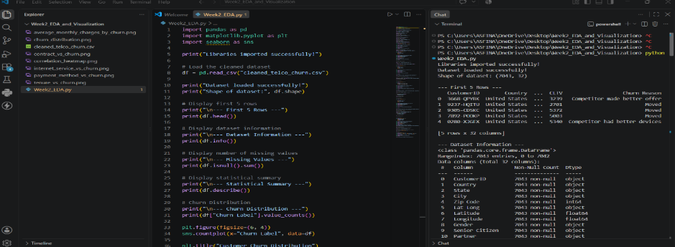
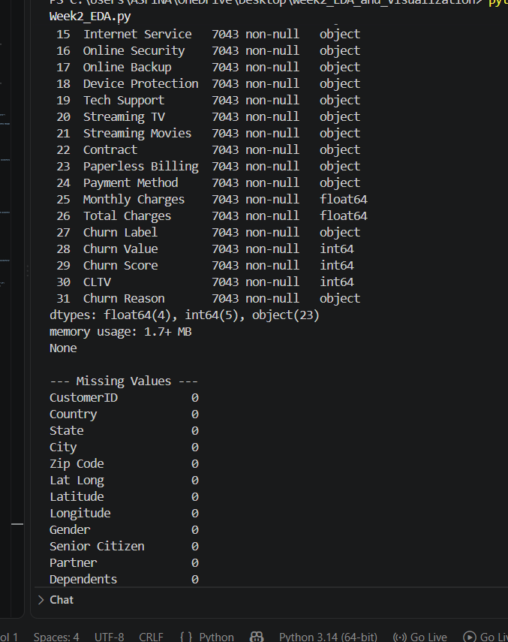
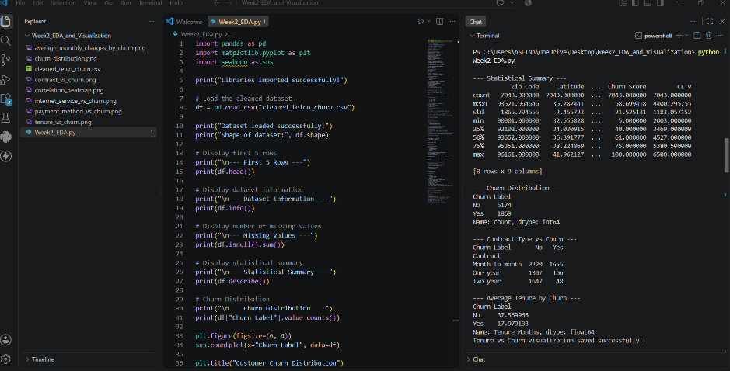
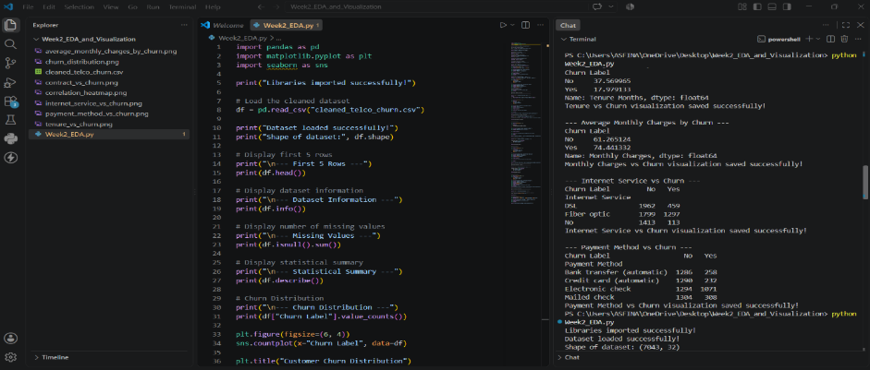
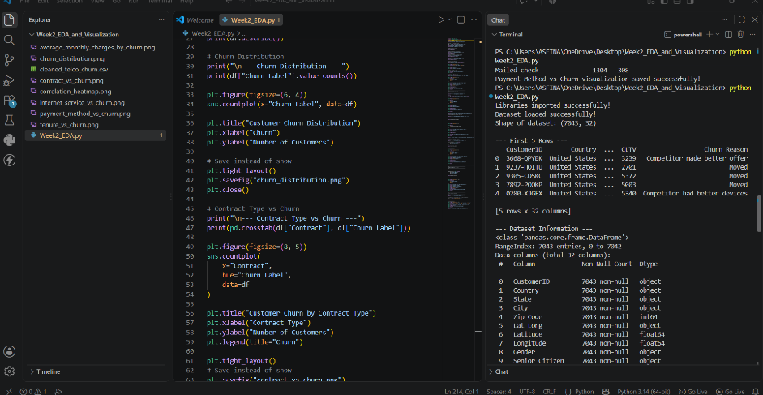
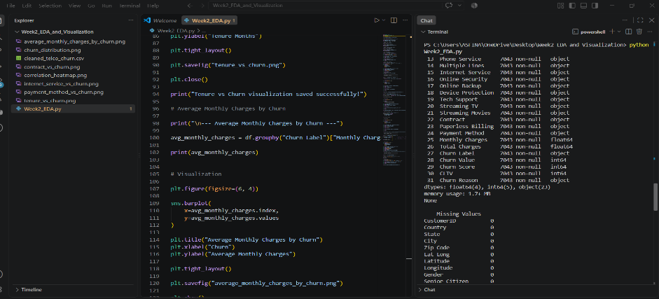
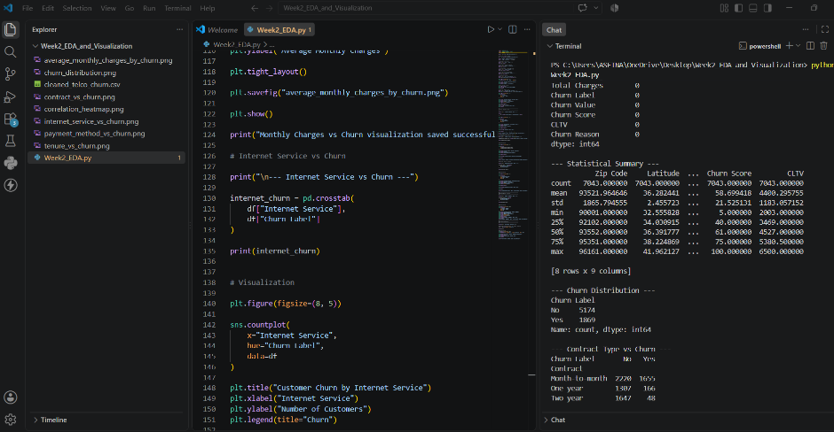
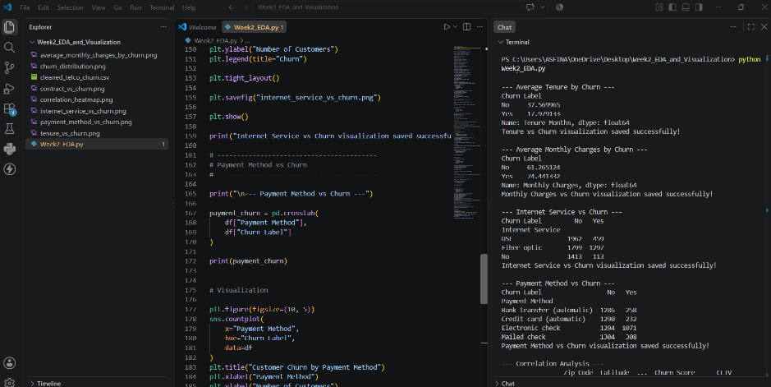
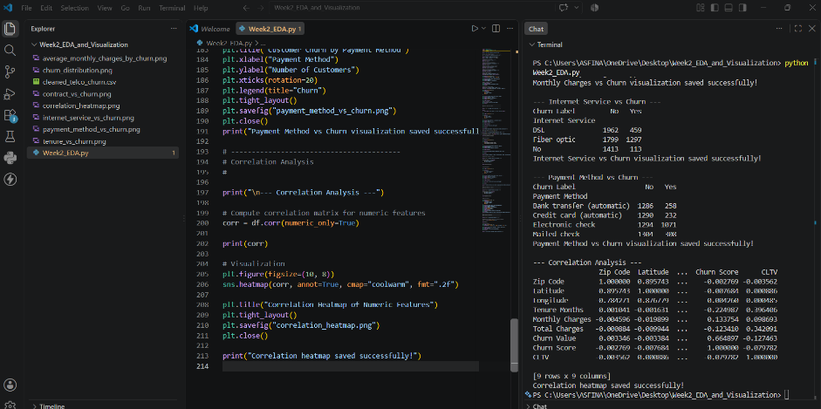

4. Insights & Discussion
- Month-to-month contracts → highest churn.
- Short tenure & high monthly charges → churn risk.
- Fiber optic users churn more than DSL.
- Electronic check payments → highest churn.
- Correlation confirms tenure and charges are strong churn drivers.
These findings highlight the customer segments most at risk and provide direction for retention strategies.

5. Conclusion
Based on the analysis, the following recommendations are proposed:
- Encourage longer contracts to reduce churn.
- Improve fiber optic service quality to retain customers.
- Offer discounts or loyalty rewards for high-charge customers.
- Promote secure auto-pay methods to reduce churn among electronic check users.
Implementing these strategies can reduce churn, increase customer lifetime value, and improve overall business performance.

